MONTH Analytics

COMPANY NAME

## Overview

This is a brief overview of the month with reactions to how your content performed, and is intended to give you a birds-eye view of the content -- or an executive summary for decision makers and managers.

|  |  |  |  |  |
| --- | --- | --- | --- | --- |
|  | Clicks | Reach | Engagement | Growth |
| FB |  |  |  |  |
| TW |  |  |  |  |
| IG |  |  |  |  |

## Facebook Overview

The chart below shows the most engaging posts and the highest reach posts on Facebook in (MONTH).

* One “win” from the month
* Statistics from above in context. For example: Organic reach increased almost 42%! That’s a great start for our Facebook activity.

### Takeaways

* List ways you can improve content.
* List content that did well and didn’t perform the way you expected it. Try to decipher why.
* List ideas for future content.

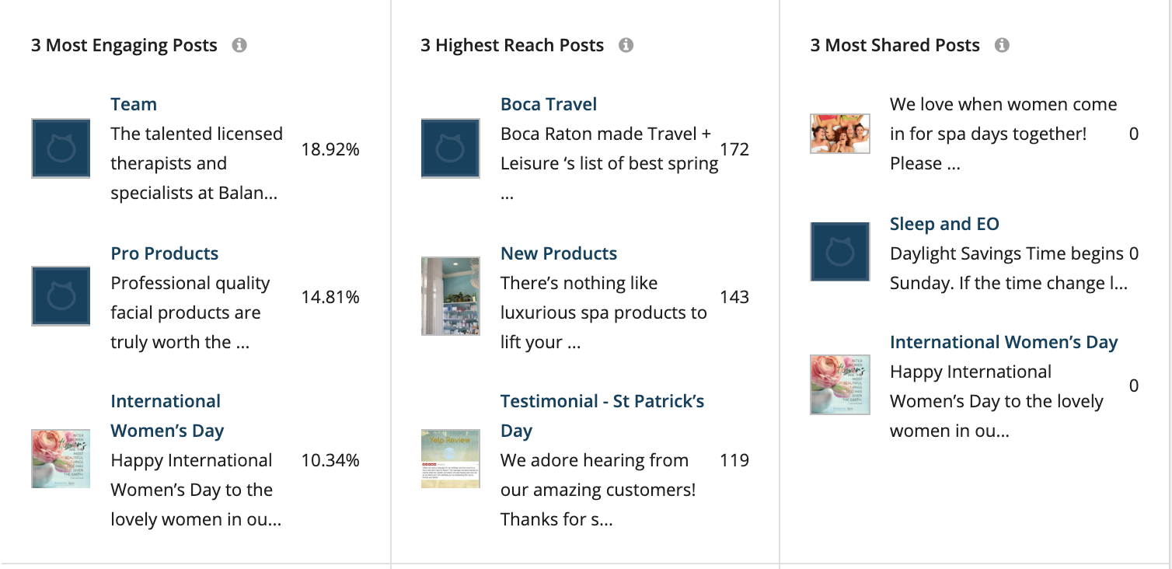

(The above photo represents a screenshot from Loomly, but you can use any analytics platform you use to find the best/ worst posts.)

## Twitter Overview

The chart below shows the most engaging posts and the highest reach posts on Facebook in (MONTH).

* One “win” from the month
* Statistics from above in context. For example: Organic reach increased almost 42%! That’s a great start for our Facebook activity.

### Takeaways

* List ways you can improve content.
* List content that did well and didn’t perform the way you expected it. Try to decipher why.
* List ideas for future content.

## Instagram Overview

The chart below shows the most engaging posts and the highest reach posts on Facebook in (MONTH).

* One “win” from the month
* Statistics from above in context. For example: *Organic reach increased almost 42%! That’s a great start for our Facebook activity.*

### Takeaways

* List ways you can improve content.
* List content that did well and didn’t perform the way you expected it. Try to decipher why.
* List ideas for future content.